From ideas to laws: understanding and discussing how new ideas for laws are initiated and passed through parliament
We are all citizens of our society. Most Australians share common values such as freedom, equality, respect, fairness and justice. Australian laws help protect Australian values and guide the everyday behaviour of citizens. If a citizen or a group disagrees with, or wants to bring about a change in a law, he or she can do so in a peaceful manner. The wearing of bike helmets and the new safe-passing distance for motorists in Queensland are examples of how individuals and groups influence the making of law.
When the federal government made new bike helmet laws in 1991, it needed to consider the points of view held by different groups within the community.
Activity 1
Explore the reasons behind the government’s decision to introduce mandatory bike helmets (note, public support was high for the introduction of the bike helmet law).
Identify and record the point of view of each community group about the proposal (note, one has been done for you).
Parents | Community members
Action groups against the wearing of helmets  Our group does not believe bike helmets should be mandatory. Research does not fully support that the wearing of bike helmets is best for public safety and welfare. | Members of parliament
Doctors | Other
Activity 2
Analyse Source 1 — Bicycling laws in Australia (page 3) and Source 2 — Identifying different points of view (page 4).
Describe the key events that might have influenced the government decision to introduce new traffic laws about safe passing distances.
New passing road laws
Activity 3
Analyse Source 1 — Bicycling laws in Australia (page 3) and Source 2 — Identifying different points of view (page 4).
Form an opinion about the new traffic laws about safe passing distances and record in one of the speech bubbles with your reason for holding this viewpoint (note, one idea has been provided to help you.)
Survey three other people in your class about their opinions on the new safe passing road laws and their reasons for holding these viewpoints.




For example, I think the new traffic laws about safe passing distances will benefit everyone. I ride my bike to school every day and I have noticed that drivers are following the new laws really well. Everyone seems to know now how to treat everyone using the road with respect. I feel safer.

Source 1 — Bicycling laws in Australia
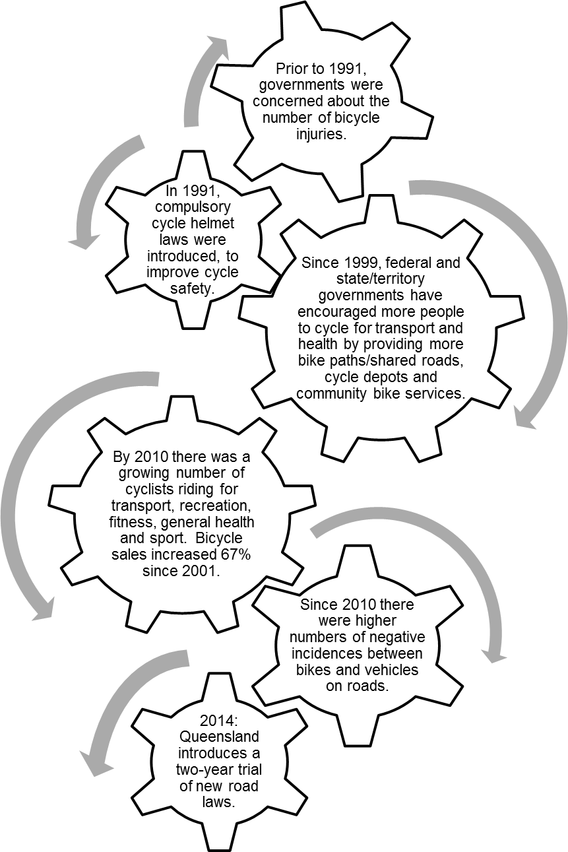

Reference: State of the Road, (CARRS), www.carrsq.qut.edu.au
Source 2 — Identifying different points of view
Background
Before introducing the new safe passing distance laws (for example, the one-metre rule), the Queensland Government set up a parliamentary committee to inquire and report on ways to improve the interactions between cyclists and other road users. It reviewed evidence from individual cyclists, motorists, road safety experts and people who have suffered personal injury from road collisions.
Government | We are deeply concerned over public safety and road-user interactions and behaviours. We have to uphold the value of respect for others in our community. | Cyclists take up too much of the road, particularly during peak hour, holding up the traffic flow and travel time for motorists. | Motorist  
Cycling is on the increase in Queensland and the present roads are not suitable to accommodate this growth. | Bicycle groups and organisations   | 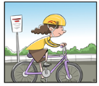  Cyclist | Bicycles are recognised ‘vehicles’ and cyclist are recognised ‘road users’ under the law. Cyclists have the right to use the roads.
  Community member | I am concerned about the number of cyclists who have been seriously injured on the road. But I am also concerned that some cyclists do not slow down at pedestrian crossings. | As the years have passed, there has been increased traffic density and higher incidences of negative interactions between bike and vehicles. Motorists have become particularly annoyed when cyclists go through red lights and stop signs. | Road safety expert  
Reference: Parliamentary Committees (Queensland Government) http://www.parliament.qld.gov.au/documents/committees/THLGC/2013/INQ-CYC/rp-39-29Nov13.pdf

